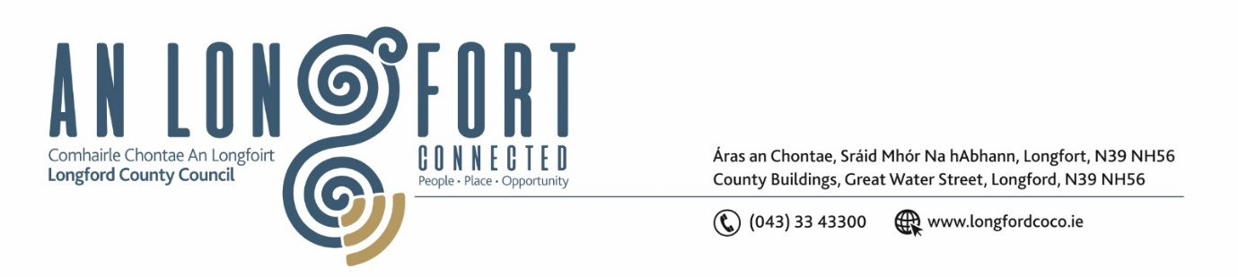

**LONGFORD MUNICIPAL DISTRICT**

**Minutes of Meeting of Longford Municipal District**

**held in the Council Chamber Aras an Chontae and via MS Teams**

**on Tuesday, 26 November 2024 at 11am**

**CATHAOIRLEACH**: Councillor Seamus Butler

**MEMBERS PRESENT**: Councillors Peggy Nolan, Uruemu Adejinmi, Niall Gannon, Martin Monaghan, Kevin Hussey, Gerry Hagan

**IN ATTENDANCE**: Mr. John Brannigan, Director of Services

Mr. David McNiff, Senior Executive Engineer

Mr. Liam Kiernan, Executive Engineer

Mr. Con Diffley, Senior Executive Engineer

Mr. Gerard Dennigan, Executive Secretary

**MEETINGS**

**ADMINISTRATOR:**  Ms. Claire McNabola

**APOLOGIES:** Ms. Lorraine McKee, Meetings Administrator

1. **ADOPTION OF MINUTES – circulated**
2. On the proposal of Councillor Peggy Nolan seconded by Councillor Martin Monaghan it was unanimously agreed to adopt Minutes of Meeting of Longford Municipal District held on Tuesday, 15 July 2024 as circulated.
3. On the proposal of Councillor Martin Monaghan seconded by Councillor Peggy Nolan it was unanimously agreed to adopt Minutes of Committee Meeting of Longford Municipal District held on Tuesday, 22 October 2024
4. On the proposal of Councillor Uruemu Adejinmi seconded by Councillor Peggy Nolan it was unanimously agreed to adopt Minutes of Meeting of Longford Municipal District held on Tuesday, 22 October 2024
5. **MATTERS ARISING FROM MINUTES**

None

1. **DECLARATION OF INTEREST BY MEMBERS**

None

1. **MANAGEMENT REPORT – as circulated.**

David McNiff updated the members with the Management Report, and it was noted.

The Members collectively complemented all projects and works that have delivered on and carried out over the past few months.

David & John answered relevant questions raised by the Members.

1. **TWINNING COMMITTEE**

Councillor Butler briefed the Members on the operations of the Twinning Committee with Noyal-Châtillon sur Seiche, Brittany France, he advised they have been requested to open a bank account for funding.

Councillor Butler also informed the Members of an upcoming Music Festival in Noyal-Châtillon sur Seiche in mid-June 2025, he would like to plan the Twinning Committee Trip around this if possible. Councillor Butler also requested that the AGM of Longford MD wouldn’t take place until after this trip, this in turn was agreed by the Members.

Councillor Butler later informed the members of a Photograph Competition been hosted by Noyal-Châtillon sur Seiche and sought approval from the Members for Longford to take part in same. This was agreed by the Members.

1. **PART 8 – NO.122 – N63 FARRANYOOGAN, LONGFORD, CO.LONGFORD**

Con Diffley briefed the Members on the proposed Part 8. The members aired their concerns in relation to the timelines, distribution to business owners, traffic etc associated with the proposed works.

John Brannigan and Con Diffley addressed any issues raised. On the Proposal of Councillor Peggy Nolan, seconded by Uruemu Adejinmi the members agreed to the Part 8 and move forward with the next phase of the project.

Con Diffley then advised the Members of the timelines for the next phase of the project.

1. **NOTICE OF MOTIONS**
2. **The following Notice of Motion was proposed by Councillor Kevin Hussey and seconded by Councillor Uruemu Adejinmi**

I call on Longford County Council to fix the number of lights not working on the canal and to fix the surface walkways where the grass is so badly overgrown.

**Response:**

We have received several reports regarding non-functional lights in this area and have referred the issue to Road Design for repair. We can confirm that the lights are now operational.

Additionally, grass-cutting along the Canal Walk from N63 towards town was completed last month. We also plan to sweep the path in the coming week to ensure it remains clean and accessible.

1. **The following Notice of Motion was proposed by Councillor Uruemu Adejinmi and seconded by Councillor Kevin Hussey**

I call on Longford County Council to assess the viability of an improved pedestrian crossing at the head of New Street in Longford Town.

**Response:**

Longford County Council will review the issues at this location and will discuss with the relevant Transport Infrastructure Ireland inspectors.

1. **The following Notice of Motion was proposed by Councillor Uruemu Adejinmi and seconded by Councillor Seamus Butler**

I call on Longford County Council to actively engage with the owners of derelict and vacant residential properties with Longford MD to promote the Croí Cónaithe scheme. Furthermore, I urge the Council to explore the option of Compulsory Purchase Orders (CPO) for eligible residential properties, with the aim of making these properties available to first-time homebuyers among the local working population.

**Response:**

The Croí Cónaithe scheme has been a very good Government Initiative. Longford County Council has received over 160 applications, largely these applications have been from outside of Longford Town. With a view to increasing applications, a new publicity campaign will be launched in the First Quarter of 2025.

**Other issues**

Gerard Dennigan reminded the Members of the Turning on of the Christmas Lights this Friday 29th November at 6pm Christmas Markets will take place on Grafton Court.

Gerard also advised the Members that the Community Support grants scheme is closing on 28 November so all receipts must be uploaded on the Submit System - any issues to contact Deirdre Skelly in Planning.

**Councillor Butler wished everyone a very Happy & Safe Christmas.**

This concluded the business of the meeting.

**Signed: ____________________**

**Claire McNabola,**

**Meetings Administrator.**

**Confirmed and adopted at Longford Municipal District Meeting held on the 25 February 2025.**

**Signed: _______________**

**Cathaoirleach**